
Lab Manual- Deploy Code to Azure App with Git Action

Table of Contents
1 OBJECTIVE 3
2 PRE-REQUISISTE 3
3 Setup Up Github Action for Code Deploy 4
3.1 Create a App Service with ASP.Net V4.8 4
3.2 Fork the Github Repo 9
3.3 Push the code to App service 9

OBJECTIVE
  - Azure App Service is an HTTP-based service for hosting web applications, REST APIs, and mobile back ends. You can develop in your favorite language, be it .NET, .NET Core, Java, Ruby, Node.js, PHP, or Python. Applications run and scale with ease on both Windows and Linux-based environments.
  - App Service not only adds the power of Microsoft Azure to your application, such as security, load balancing, autoscaling, and automated management. You can also take advantage of its DevOps capabilities, such as continuous deployment from Azure DevOps, GitHub, Docker Hub, and other sources, package management, staging environments, custom domain, and TLS/SSL certificates.
  - With App Service, you pay for the Azure compute resources you use. The compute resources you use are determined by the App Service plan that you run your apps on

PRE-REQUISISTE
- Accounts in Azure
- A local Computer with 4 CPU, 16 GB RAM, 200 GB disk space

Setup Up Github Action for Code Deploy 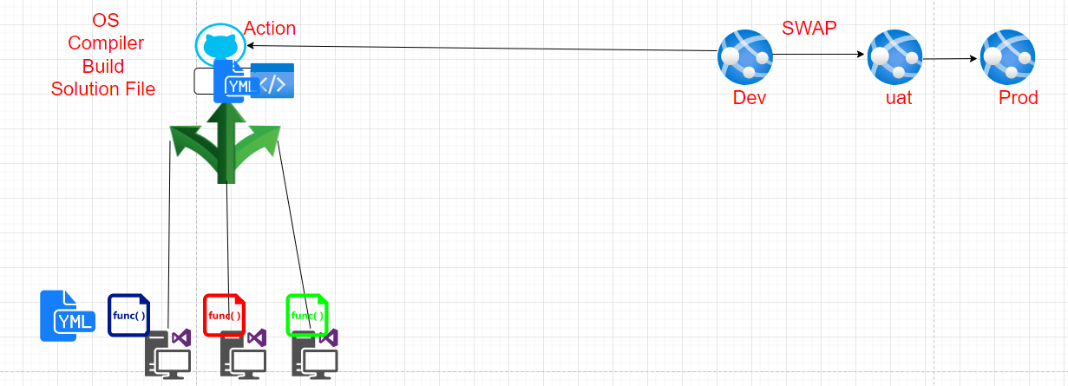

Create a App Service with ASP.Net V4.8
- Sign in to the Azure portal
- In the Search Box type app

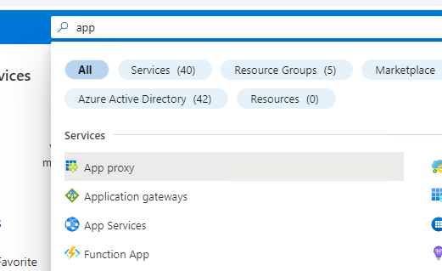
- Click App Services from search list

- In the App service Wizard
  - Subscription Name : Select your Azure Subscription
  - Resource Group Name : Select Your Resource Group or Type name of Resource Group
  - Name: type Unique name for your webapp
  - Runtime Stack: ASP.Net V4.8
  - Regions : EastUS
Click Review & Create Button
- Click Create Button
- App service Deployment begin
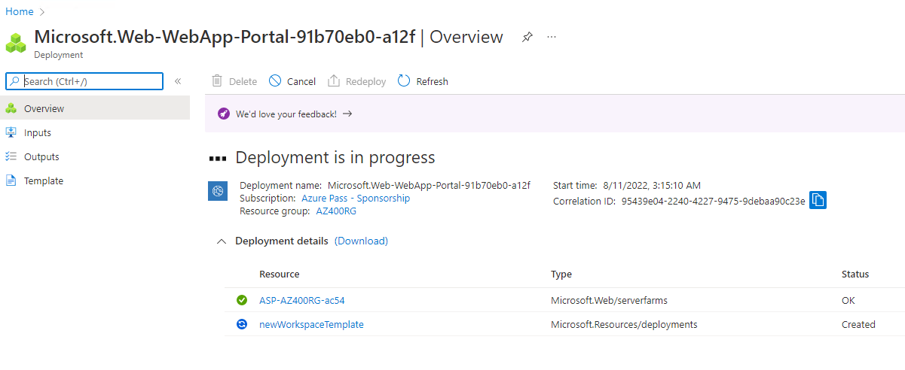
- Once deployment complete , Click Go to Resource
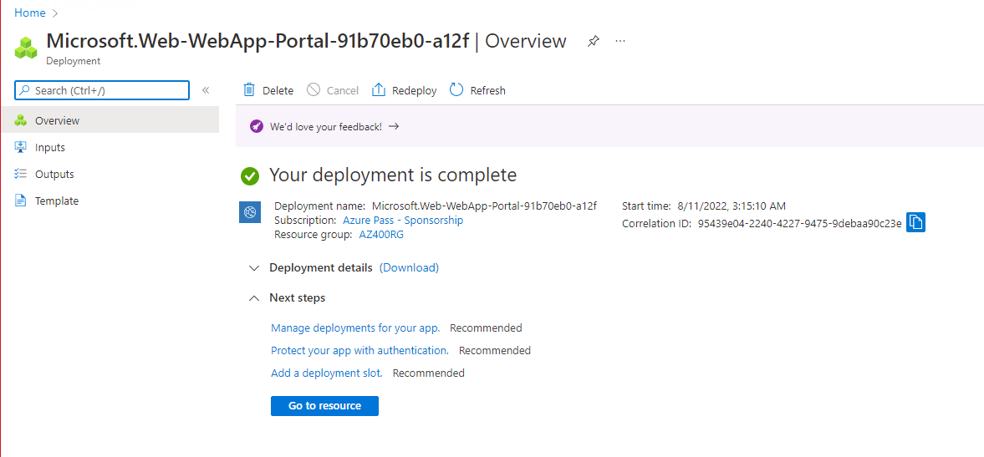
- Copy the Default URL
- You should see website similar to below
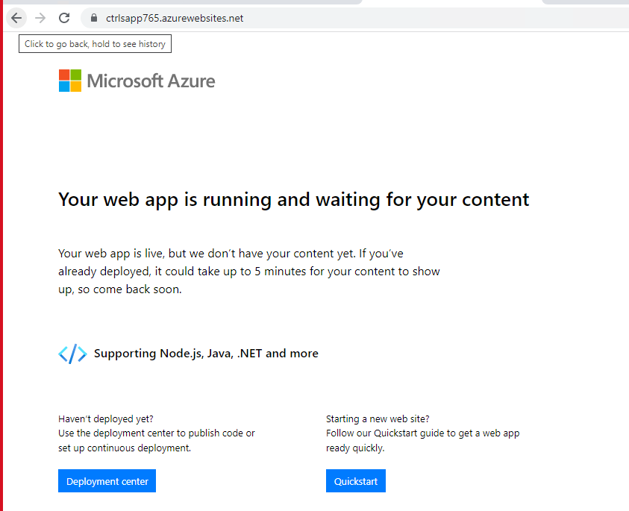

Fork the Github Repo

- Fork Code in github.com repository
https://github.com/bipeensinha/YakshithApp

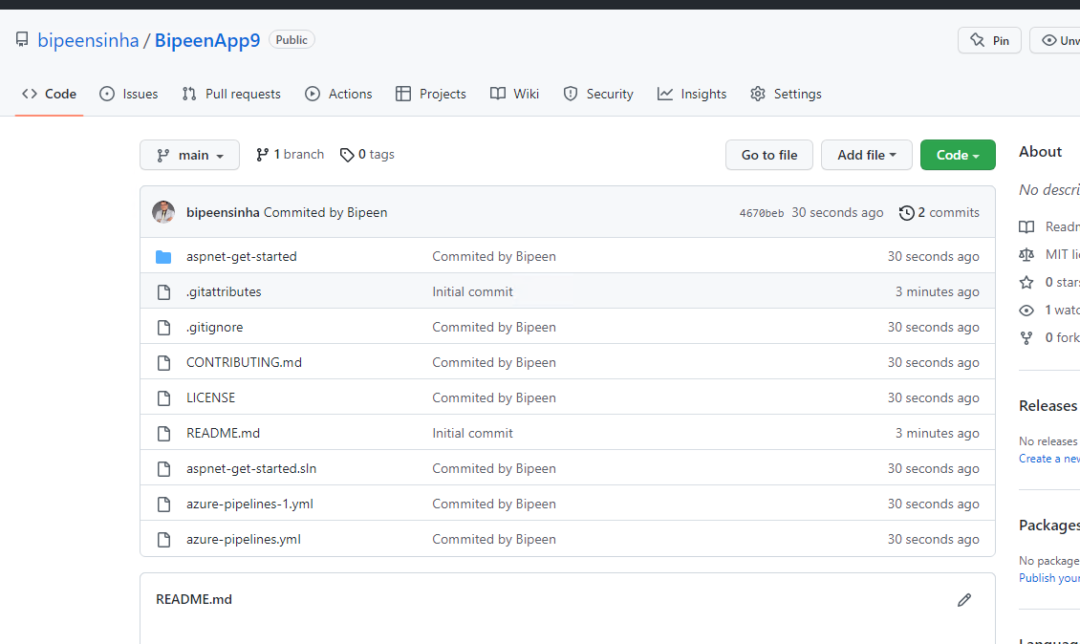

Push the code to App service

- Click Deployment center and from source drop down select GitHub. If Authorized Button appear click it and authorized it.

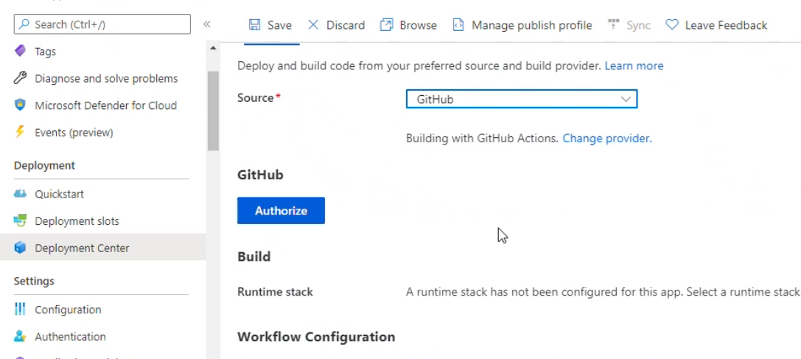

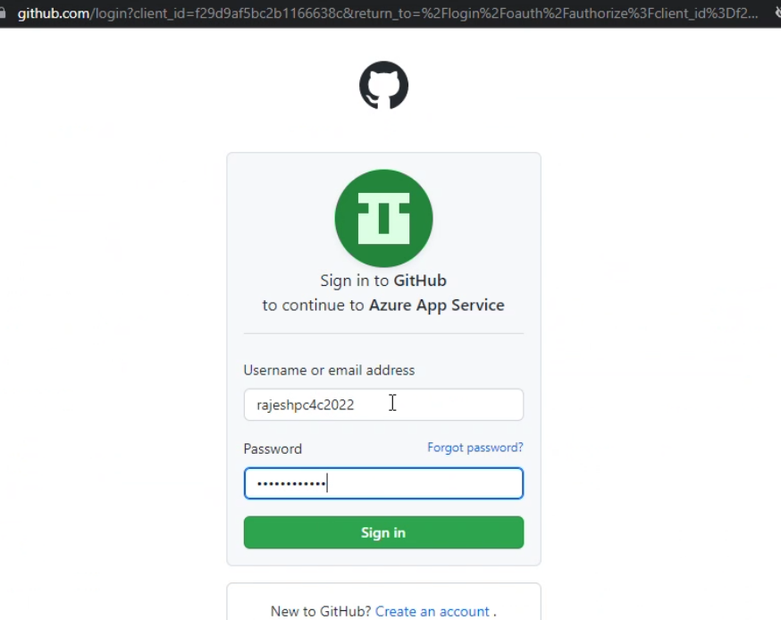

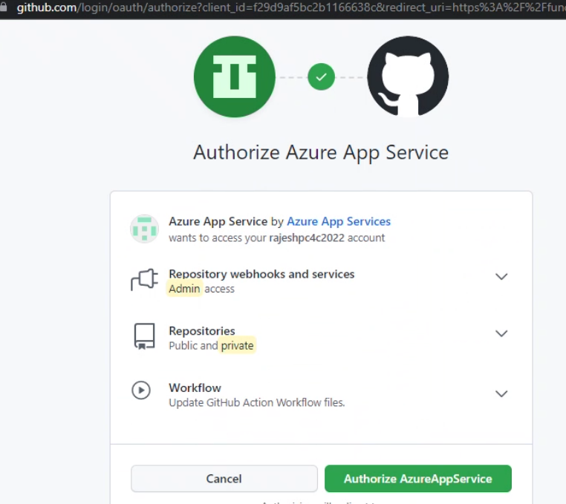

- Once you authorized , select your Organization , Repository and Branch and save your setting
- After save your setting you should get the screen similar as below
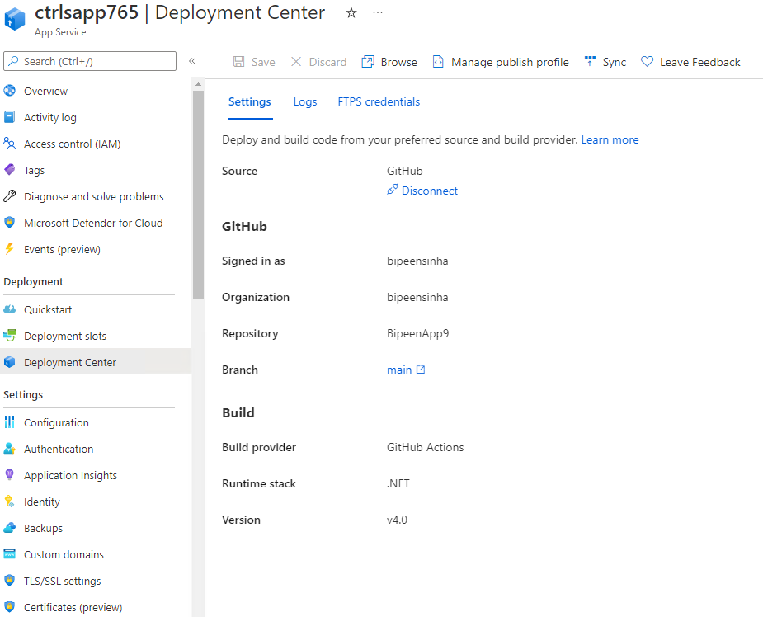
- Go Back to Guthub.com and in repository click Action Tab. You should see workflow has been triggered

- In few Minute Build process should start

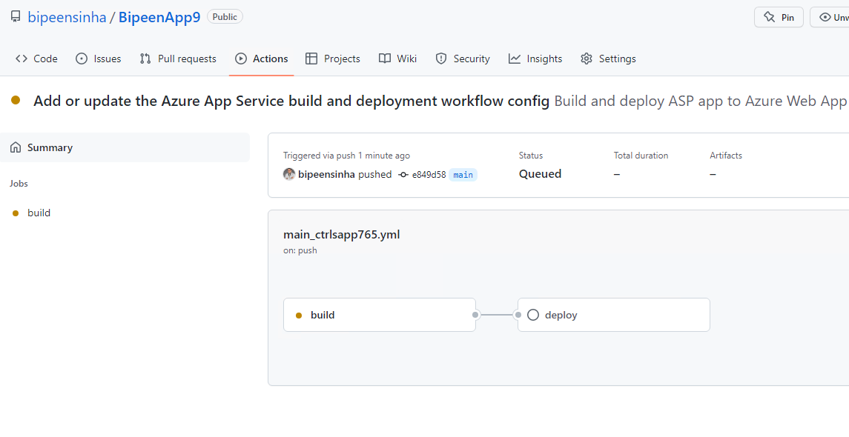
- Click the Build process to see its details

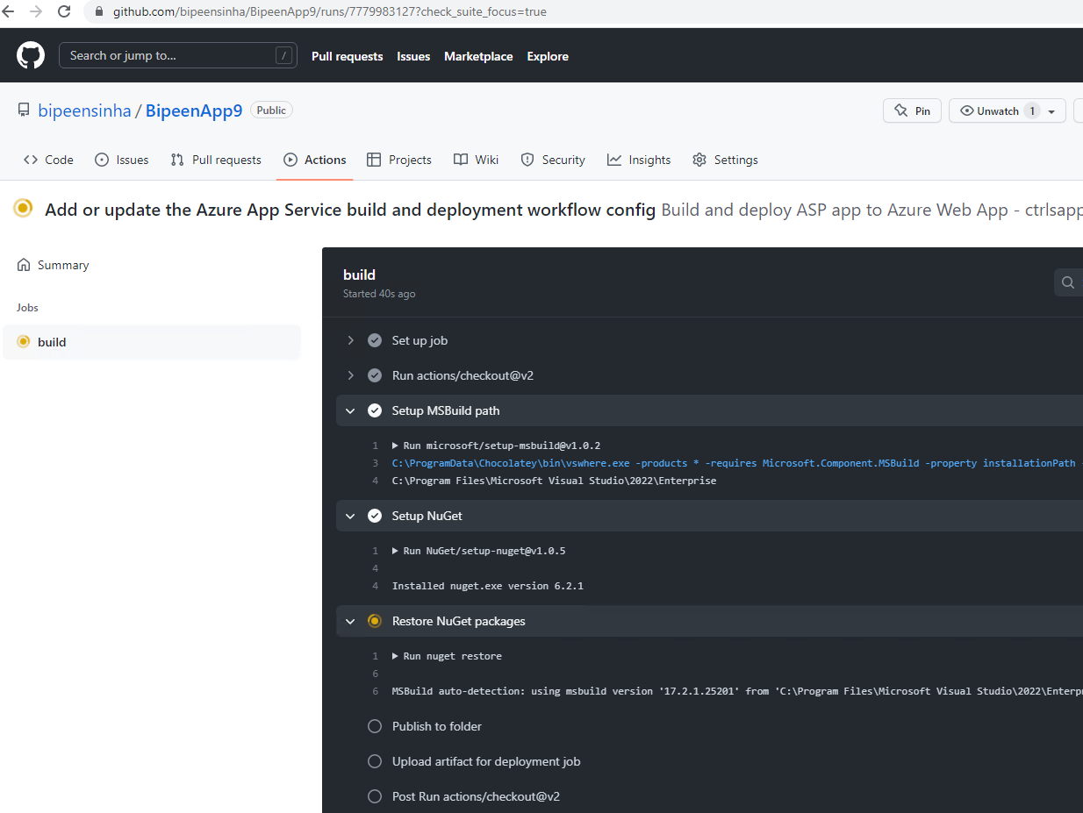
- Once the Build process completed Deploy process should start

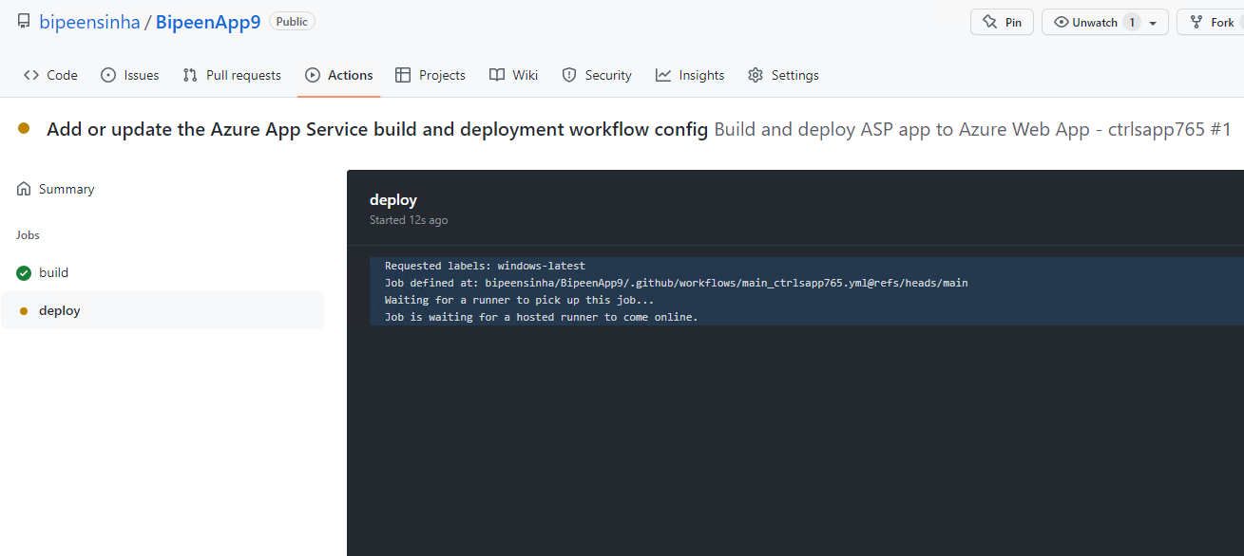

- In few Minutes both Build and deploy Completed

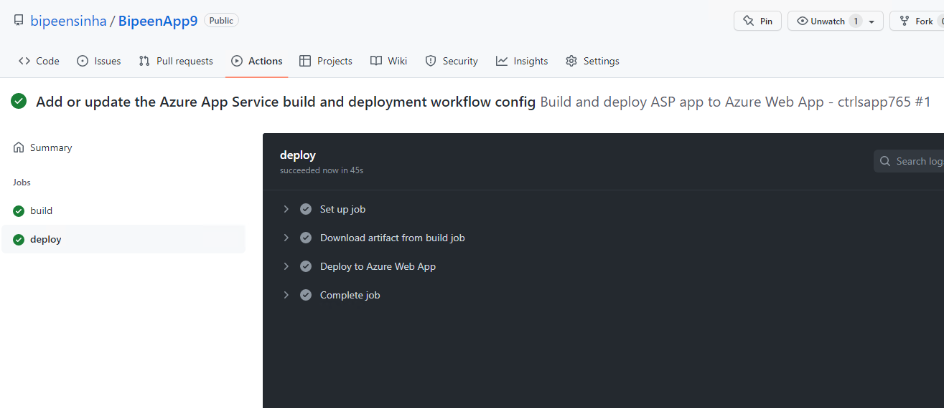

- Now go and Check dev URL

